
HWA CHONG INSTITUTION
C2 Preliminary Examination
Higher 2

CANDIDATE NAME |  |  |  |  |  |  | CT GROUP | 09S
CENTRE NUMBER |  |  |  |  |  |  | INDEX NUMBER

CHEMISTRY  Paper 2 Structured Questions  Candidates answer on the Question Paper.  Additional Materials: Data Booklet. | 9647/02  21 September 2010  2 hours

INSTRUCTIONS TO CANDIDATES
1) Write your name and CT class clearly in the spaces at the top of this page.
2) Answer all questions in the spaces provided in this Question Booklet.

INFORMATION FOR CANDIDATES
The number of marks is given in brackets [ ] at the end of each question or part question.
A Data Booklet is provided.
You may use a calculator.
You are reminded of the need for good English and clear presentation in your answers.

For Examiner’s Use
1 | / 12
2 | / 9
3 | / 14
4 | / 12
5 | / 12
6 | / 13
Total | / 72

Answer all the questions in the spaces provided.
1 | The equations for the complete combustion of the first five members of the alcohol homologous series are shown below.
 | methanol |  |  | CH₃OH(l) |  | + 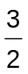O₂(g) | → | CO₂(g) + 2H₂O(l)
 | ethanol |  |  | CH₃CH₂OH(l) |  | + 3O₂(g) | → | 2CO₂(g) + 3H₂O(l)
 | propan-1-ol |  |  | CH₃CH₂CH₂OH(l) |  | + 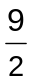O₂(g) | → | 3CO₂(g) + 4H₂O(l)
 | butan-1-ol |  |  | CH₃CH₂CH₂CH₂OH(l) |  | + 6O₂(g) | → | 4CO₂(g) + 5H₂O(l)
 | pentan-1-ol |  |  | CH₃CH₂CH₂CH₂CH₂OH(l) |  | + 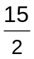O₂(g) | → | 5CO₂(g) + 6H₂O(l)
 | You are to plan an experiment to determine the enthalpy change of combustion, ΔH_{c}, under laboratory conditions, for each of the five alcohols, using the apparatus and information below.
 | 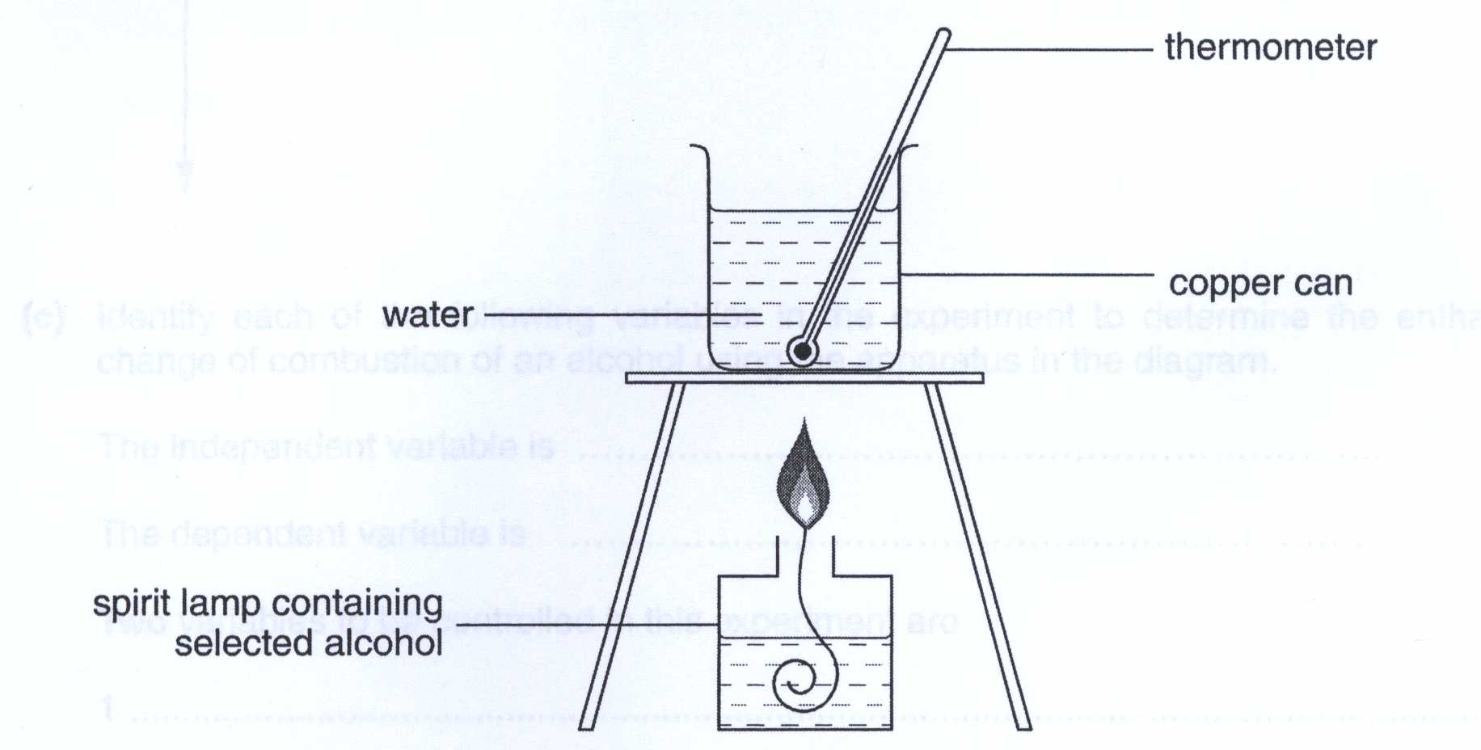
 | (a) | Inspection of the products of the five equations shows that from methanol to pentan-1-ol there is one more mole of CO₂ and one more mole of H₂O produced per mole of alcohol than the alcohol above it.
 |  | What difference between the structures of adjacent alcohols is responsible for these additional combustion products?
 |  | ………………………………………………………………………………………………….…………
 |  | ………………………………………………………………………………………………….…………
 |  |  | [1]
 | (b) | Based on your answer in (a), suggest the trend in ∆H_{c,} of these five alcohols with a sketch on the grid below.
∆H_{c}
Number of carbon atoms in the alcohols
1 2 3 4 5

 |  |  | [1]
 | (c) | Using the apparatus in the diagram an experiment to determine the enthalpy change of combustion of any particular alcohol can be carried out. The independent variable in the experiment is the mass of the alcohol used during combustion.
 |  | Identify the dependent variable in this experiment.
 |  | ………………………………………………………………………………………………….…………
 |  | Identify one variable to be controlled in this experiment.
 |  | ………………………………………………………………………………………………….…………
 |  |  | [2]
 | (d) | You are to plan a step-by-step method to determine the enthalpy change of combustion, ∆H_{c}, for each of the alcohols in turn. You should use the apparatus shown in the diagram on page 2 and any other apparatus required that is normally found in a school laboratory.
 |  | Your method should cover the following points:
- the precision of the apparatus to be used
- the way in which the independent variable is varied between experiments
- measurements of the dependent variable
- appropriate quantities to be used
- the raw data to be collected
- how this data is to be processed for ethanol

Given:
- 4.2 J of heat is needed to raise the temperature of 1 cm³ (1 g) of water by 1 ºC
- Specific heat capacity of copper = 0.385 J g⁻¹ K⁻¹
 |  | Method
 |  | ………………………………………………………………………………………………….…………
 |  | ………………………………………………………………………………………………….…………
 |  | ………………………………………………………………………………………………….…………
 |  | ………………………………………………………………………………………………….…………
 |  | ………………………………………………………………………………………………….…………
 |  | ………………………………………………………………………………………………….…………
 |  | ………………………………………………………………………………………………….…………
 |  | ………………………………………………………………………………………………….…………
 |  | ………………………………………………………………………………………………….…………
 |  | ………………………………………………………………………………………………….…………
 |  | ………………………………………………………………………………………………….…………
 |  | ………………………………………………………………………………………………….…………
 |  | ………………………………………………………………………………………………….…………
 |  | ………………………………………………………………………………………………….…………
 |  | ………………………………………………………………………………………………….…………
 |  | ………………………………………………………………………………………………….…………
 |  |  | [4]
 |  | Processing of raw data for ethanol
 |  | [M_{r}: CH₃CH₂OH, 46.0]
 |  |  | [2]
 | (e) | Prepare a single table to show, for each alcohol, all the measurements obtained directly from the experiment and the information processed from these data.
 |  | Your table should show the correct units for each of the headings.
 |  |  | [1]
 | (f) | (i) | Identify and assess a risk associated with this experiment.
 |  |  | ……………………………………………………………………………………………………
 |  |  | ……………………………………………………………………………………………………
 |  | (ii) | Describe how the risk in (f)(i) can be kept to a minimum.
 |  |  | ……………………………………………………………………………………………………
 |  |  | ……………………………………………………………………………………………………
 |  |  | [1]
 |  |  | [Total: 12]
2 | Copper and iodine are both shiny crystalline solids. The crystal structures of copper and iodine are both face-centred cubic. The diagram shows the arrangement of the particles in this type of crystal lattice.
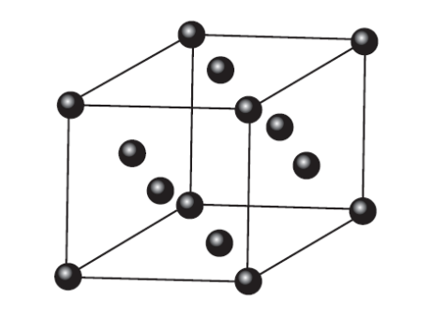
In the diagram above, the particles present are represented by .

 | (a) | (i) | What type of particles is present in the copper crystal? State the interactions within the crystal.
 |  |  | particle ……………………………………………………………………………………………
 |  |  | interactions ………………………………………………………………………………………
 |  | (ii) | What type of particles is present in the iodine crystal? State the interactions between the particles.
 |  |  | particle ……………………………………………………………………………………………
 |  |  | interactions ………………………………………………………………………………………
 |  | [2]
 | (b) | Explain why copper is malleable and ductile.
 |  | ………………………………………………………………………………………………….…………
 |  | ………………………………………………………………………………………………….…………
 |  |  | [1]
 | (c) | Give an example of another physical property that is present in one of the above solids but absent in the other. Explain.
 |  | Physical property ……………………………………………………………………………………….
 |  | Reason ……………………………………………………………………………………….………….
 |  | ……………………………………………………………………………………….………….
 |  | [2]
 | (d) | A sample of copper contains the two isotopes ⁶³Cu and ⁶⁵Cu only. An experiment is conducted to find the relative atomic mass of this sample and is found to be 63.9.
 |  | (i) | Explain why the value found is not a whole number.
 |  |  | ……………………………………………………………………………………………………
 |  | (ii) | Suggest why the relative atomic mass stated above differs from the value obtained from the periodic table.
 |  |  | ……………………………………………………………………………………………………
 |  |  | [2]
 | (e) | When separate beams of ⁶³Cu²⁺ and ¹²⁷I⁻ are passed through an electric field in the apparatus below, they behave differently.
 | 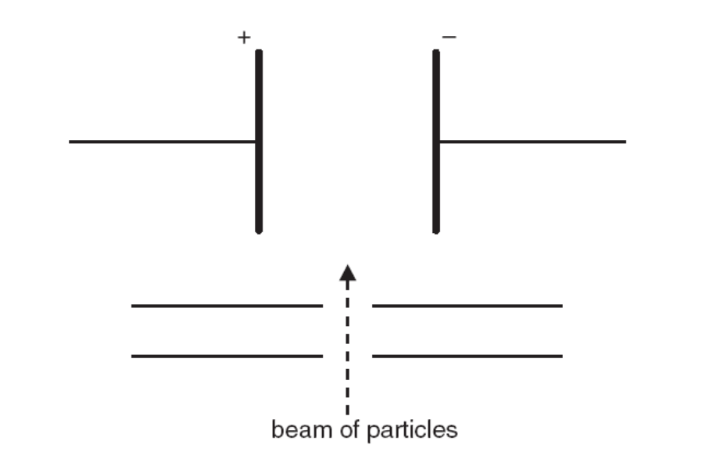
 |  | (i) | Sketch on the diagram above how the paths taken by beams of ⁶³Cu²⁺ and ¹²⁷I⁻ in the presence of electric field.
 |  | (ii) | Given that the angle of deflection of the Cu²⁺ beam is 7.0º, calculate the angle of deflection of the I⁻ beam, correct to 1 decimal place.
 |  |  | Angle of deflection ……………………..
 |  |  | [2]
 |  |  | [Total: 9]
3 | (a) | (i) | Ammonia, NH₃, is one of the most commonly produced industrial chemicals. One mole of ammonia gas occupies only 22.09 dm³ at standard temperature and pressure.
 |  |  | Give a reason why ammonia has a smaller molar volume than an ideal gas.
 |  |  | ……………………………………………………………………………………………………..
 |  |  | ……………………………………………………………………………………………………..
 |  | (ii) | Ammonia can be liquefied by pressure alone if it is below the 'critical temperature' of 133 ºC. Above this critical temperature no amount of pressure will liquefy ammonia.
 |  |  | Suggest an explanation for this.
 |  |  | ……………………………………………………………………………………………………..
 |  |  | ……………………………………………………………………………………………………..
 |  |  | [2]
 | (b) | Ammonium ion is acidic in aqueous solution.
 |  | NH₄⁺(aq) + H₂O(l)  NH₃(aq) + H₃O⁺(aq)
 |  | (i) | Which feature of this equation tells you that the ammonium ion is a weak acid?
 |  |  | ……………………………………………………………………………………………………
 |  | (ii) | Write the expression for the acid dissociation constant, K_{a}, of the ammonium ion.
 |  | (iii) | Calculate the pH of a 0.30 mol dm⁻³ solution of NH₄Cl.  State any assumptions you have made.  [K_{b} for the ammonia is 1.78 × 10⁻⁵ mol dm⁻³ at 25 ºC]
 |  | (iv) | Use the data in the following table to suggest a suitable indicator for the titration of ammonia solution with hydrochloric acid. Justify your answer.
 |  |  |  |  | Indicator |  | pK_{In}
 |  |  |  |  | Thymol blue |  | 1.7
 |  |  |  |  | Bromocresol green |  | 4.7
 |  |  |  |  | Bromothymol blue |  | 7.0
 |  |  |  |  | Phenol red |  | 7.9
 |  |  |  |  | Thymolphthalein |  | 9.7
 |  |  | ……………………………………………………………………………………………………
 |  |  | ……………………………………………………………………………………………………
 |  |  | ……………………………………………………………………………………………………
 |  |  | [6]
 | (c) | (i) | Ammonia acts as a nucleophile in its reaction with bromoethane to form ethylamine CH₃CH₂NH₂.  Ethylamine reacts with aqueous ethanoic acid and ethanoyl chloride to give K and L respectively.  Draw the structural formula of K and L
 |  | 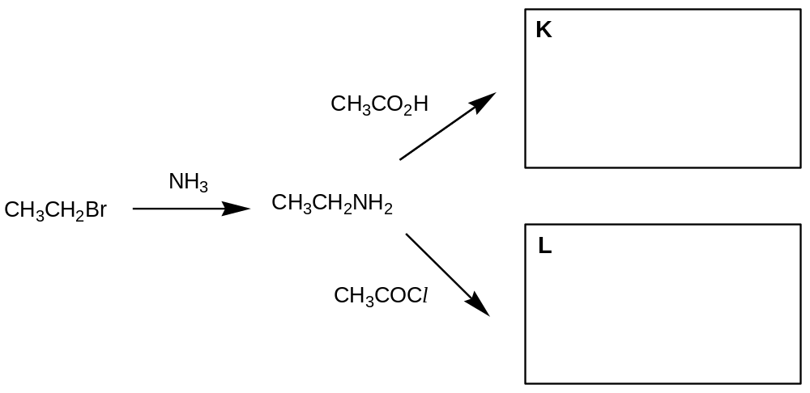
 |  | (ii) | A by-product of the reaction of bromoethane with ammonia is compound M, which has the formula C₈H₂₀NBr and gives an immediate precipitate with aqueous silver nitrate.  Suggest the structural formula of compound M.
 |  |  | [3]
 | (d) | Arrange the following compounds in order of increasing pK_{b} value. Explain your answer.  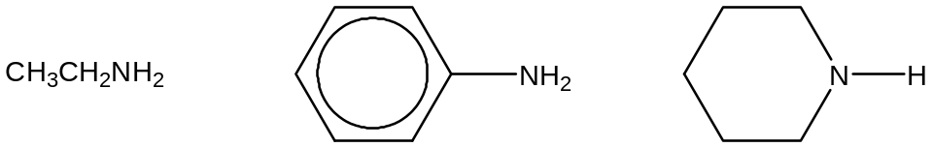
 |  |  | ……………………………………………………………………………………………………
 |  |  | ……………………………………………………………………………………………………
 |  |  | ……………………………………………………………………………………………………
 |  |  | ……………………………………………………………………………………………………
 |  |  | ……………………………………………………………………………………………………
 |  |  | ……………………………………………………………………………………………………
 |  |  | [3]
 |  |  | [Total: 14]

BLANK PAGE

4 | The use of the Data Booklet is relevant to this question.  Chromium is the Earth’s 21st most abundant element and the 6th most abundant transition metal.
 | (a) | The most common oxidation state of chromium is +3. Write an equation, with state symbols, to show a possible way of converting chromium metal to chromium in its +3 oxidation state.
 |  | ………………………………………………………………………………………………….…………
 |  |  | [1]
 | (b) | (i) | Hydrated chromium(III) chloride exists as isomers, with the general formula of CrCl₃.6H₂O. Each of the isomers is of a different colour. One such isomer is the hydrated dark green compound [CrCl₂(H₂O)₄]Cl.2H₂O.  Give the formula of two other isomers of hydrated chromium(III) chloride.
 |  |  | Isomer 1: ………………………………………………………………………
 |  |  | Isomer 2: ………………………………………………………………………
 |  | The following are some reactions of chromium(III) chloride.
 |  | 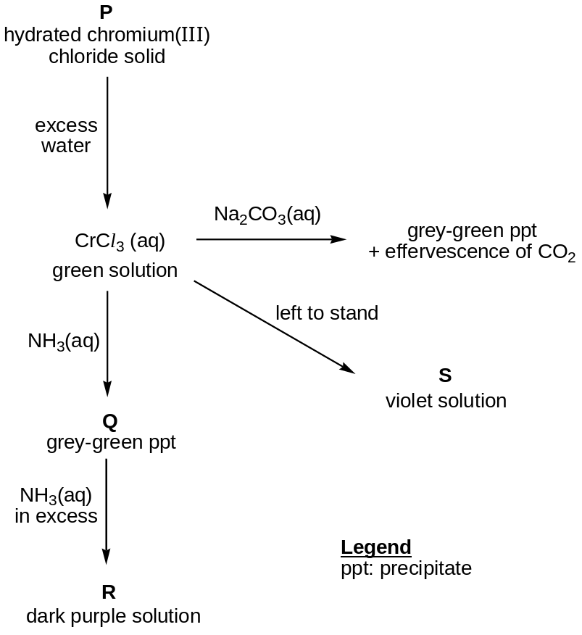
 |  | (ii) | Explain why carbon dioxide is evolved when Na₂CO₃(aq) is added to aqueous chromium(III) chloride. Include any relevant equations in your answer.
 |  |  | ……………………………………………………………………………………………………
 |  |  | ……………………………………………………………………………………………………
 |  |  | ……………………………………………………………………………………………………
 |  | (iii) | Identify the grey-green precipitate Q.
 |  |  | ……………………………………………………………………………………………………
 |  | (iv) | Suggest a formula for the complex ion present in R.
 |  |  | ……………………………………………………………………………………………………
 |  | (v) | It is found that chromium still has an oxidation state of +3 in compound S. From this information and your knowledge of transition metal chemistry, suggest what has happened to cause the colour of the solution to change from green to violet.
 |  |  | ……………………………………………………………………………………………………
 |  |  | ……………………………………………………………………………………………………
 |  |  | ……………………………………………………………………………………………………
 |  |  | [8]
 | (c) | A student conducted an experiment where he reacted zinc metal with a solution of acidified dichromate(VI) ions. He observed several changes in colour: the orange solution first turned green, then bright blue, and eventually turned back to green.
 |  | Use E values from the Data Booklet to explain all the colour changes that are taking place.
 |  |  | [3]
 |  |  | [Total: 12]
5 | (a) | Bromoethane, C₂H₅Br, is hydrolysed by aqueous sodium hydroxide. The rate of reaction can be determined by withdrawing samples of the solution at known times, and titrating them with aqueous nitric acid.  Two sets of experiments were performed where the initial concentration of the bromoethane was varied while the initial concentration of the sodium hydroxide was  0.1 mol dm^{–3} for both experiments.  The results obtained are shown in the graphs below.
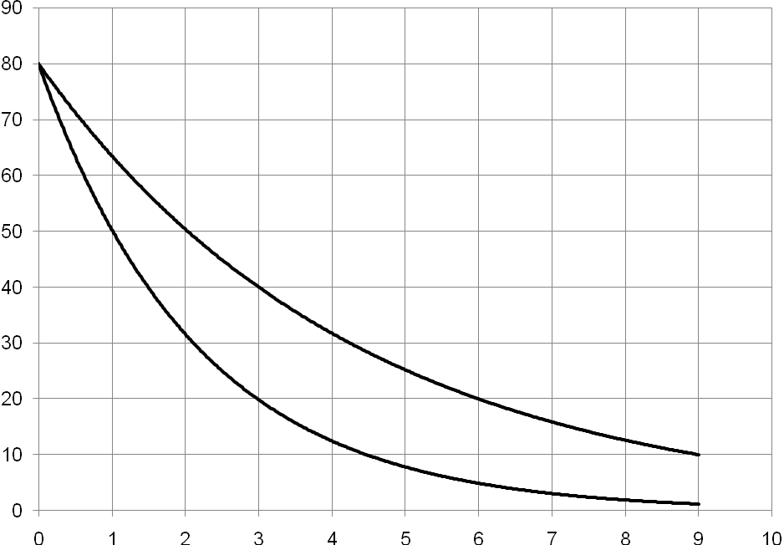
Time / min
Volume of nitric acid / cm^{–3}
[C₂H₅Br] = 1.0 mol dm^{–3}
[C₂H₅Br] = 2.0 mol dm^{–3}

Volume of nitric acid / cm³

 |  | (i) | Using the graph where [C₂H₅Br] = 1.0 mol dm^{–3}, find the order of reaction with respect to aqueous sodium hydroxide.
 |  | (ii) | Using the graphs above, deduce the order of reaction with respect to bromoethane.
 |  | (iii) | Hence, write down the rate equation for this reaction.
 |  |  | [5]
 | (b) | (i) | With reference to (a)(iii), describe the mechanism of this hydrolysis reaction.
 |  | (ii) | Using the axes below, sketch and label the reaction pathway diagram for the mechanism you have described in (b)(i).
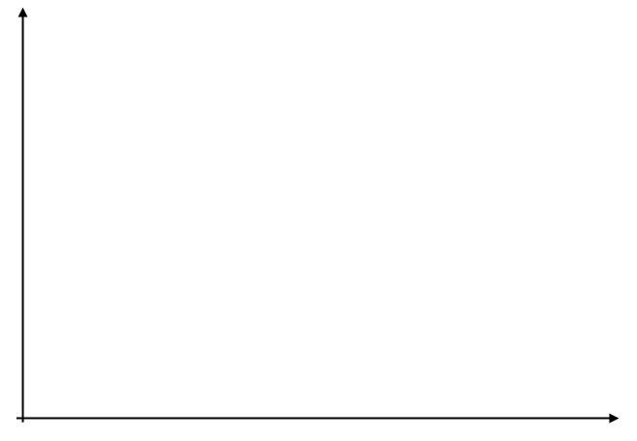
Progress of reaction

Energy

 |  | (iii) | How would the experimental results in (a) differ if the experiment is repeated using iodoethane instead of bromoethane? Explain.
 |  |  | ……………………………………………………………………………………………………
 |  |  | ……………………………………………………………………………………………………
 |  |  | ……………………………………………………………………………………………………
 |  |  | [7]
 |  |  | [Total: 12]
6 | (a) | (i) | Complete the following reaction scheme which starts with compound T, which is optically active and has a molecular formula of C₆H₁₂O₂.  Write the structural formula of the organic compounds T, W, X and Z in the boxes below.

 |  | T
 | U |  | excess conc.  H₂SO₄, 170ºC |  |  |  | X
V  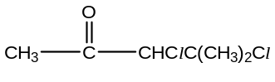 |  | 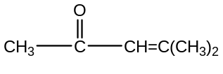 |  |  |  | Step III | X
 | Step I |  |  |  |  | Step III
 |  | cold, dil.  MnO₄⁻/OH⁻ |  |  |  |  | Y  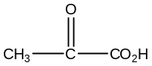
 | Step II | W
Conc. H₂SO₄,
heat

 |  |  |  |  |  | Z

 |  | (ii) | State the reagents and conditions used in step I, step II and step III.
 |  |  |  | Reagents and conditions
 |  |  | Step I
 |  |  | Step II
 |  |  | Step III
 |  |  | [7]
 | (b) | (i) | Name the two functional groups in T.
 |  |  | ……………………………………………………………………………………………………..
 |  | (ii) | Describe two laboratory tests which distinguish between T, U and V.  For each test, state the reagents you would use, and the observations you would make with each compound undergoing the test.  Test 1:  Reagents and conditions: ……………………………………………………………………….  Observations: ……………………………………………………………………………………..  ………………………………………………………………………………………………………  Test 2:  Reagents and conditions: ……………………………………………………………………….  Observations: ……………………………………………………………………………………..  ………………………………………………………………………………………………………
 | (c) | S is an isomer of U with the formula, CH₃CH₂COC₃H₅, which exhibits cis-trans isomerism. Draw the possible structures of S.
 |  |  | [2]
 |  |  | [Total: 13]

BLANK PAGE

